AutomatedTricycle Fare Meter

A Thesis Proposal

Presented to the Faculty of the

Information and Communications Technology Program

STI College Recto

In Partial Fulfilment

of the Requirements for the Degree

Bachelor of Science in Computer Engineering

John Elhie G. Cataga

Juluis M. Dela Vega

Jerome Gabat

Apple Jean M. Garcia

November 2019

ENDORSEMENT FORM FOR PROPOSAL DEFENSE

TITLE OF RESEARCH: Automatic Tricycle Fare Meter

NAME OF PROPONENTS: John Elhie G. Cataga

Juluis M. Dela Vega

Jerome B. Gabat

Apple Jean M. Garcia

In Partial Fulfilment of the Requirements

for the degree Bachelor of Science in Computer Engineering

has been examined and is recommended for Proposal Defense.

ENDORSED BY:

Engr. Elizier L. Obamos ME. CoE

Thesis Adviser

APPROVED FOR PROPOSAL DEFENSE:

Engr. Elizier L. Obamos ME. CoE

Thesis Coordinator

NOTED BY:

Engr. Elizier L. Obamos ME. CoE

Program Head

November 2019

# APPROVAL SHEET

This thesis proposal titled: Automatic Tricycle Fare Meterprepared and submitted by John Elhie G. Cataga; Jerome B. Gabat; and Apple Jean M. Garcia, in partial fulfilment of the requirements for the degree of Bachelor of Science in Computer Engineering, has been examined and is recommended for acceptance an approval.

Engr. Elizier L. Obamos ME. CoE

Thesis Adviser

Accepted and approved by the Thesis Review Panel

in partial fulfilment of the requirements for the degree of

Bachelor of Science in Computer Engineering

|  |  |
| --- | --- |
| Engr. Ric E. Cambe | Engr. MachrisCzereanah P. Flores |
| Panel Member | Panel Member |

Engr. Barbra Ianne H. Embile

Lead Panelist

Noted:

|  |  |
| --- | --- |
| Engr. Elizier L. Obamos ME. CoE | Engr. Elizier L. Obamos ME. CoE |
| Thesis Coordinator | Program Head |

November 2019

# Table of Contents

|  |  |  |
| --- | --- | --- |
|  | | Page |
| Title Page | | i |
| Endorsement Form for Proposal Defense | | ii |
| Approval Sheet | | iii |
| Table of Contents | | iv |
| Introduction | | 1 |
|  | Background of the problem | 2 |
|  | Overview of the current state of technology | 3 |
|  | Objectives of the study | 5 |
|  | Scope and limitations of the study | 6 |
| Literature Review | | 8 |
|  | Review of related literature, studies or systems | 8 |
|  | Synthesis | 11 |
| Methodology | | 13 |
|  | Methodology | 13 |
|  | Hardware/Software | 15 |
|  | Calendar of Activities | 34 |
|  | Budgetary Estimate | 35 |
|  | Human Resources | 36 |
| References | | 44 |

# Introduction

A tricycle, often abbreviated to trike, is a human-powered (or gravity-powered)three-wheeled vehicle. Some tricycles, such as cycle rickshaws (for passenger transport) and freight trikes, are used for commercial purposes, especially in the developing world, particularly Africa and Asia. Tricycles are favoured by children and senior adults for their apparent stability versus a bicycle. Motorized tricycles, or simply tricycles, are an indigenous form of the auto rickshaw and are a common means of public or private transportation in the Philippines. These public utility vehicles either ply a set route or are for-hire, like taxis. According to the Boracay Budget Travel website says of the motorized tricycle, "The tricycle is the most popular means of transport in small towns and cities, especially in the rural areas. Tricycles are built in a variety of styles, which differ from city to city, and are usually made locally by building a sidecar and affixing it to an imported motorcycle. Usually both the cycle and sidecar are covered, but not always by the same roof. Larger companies, such as Fitcor Marketing, also manufacture passenger tricycles. They are built with more seats with the motor situated at the back, rather than below the driver as per a motorcycle.

Motorcycle taxis, sidecar, habal-habal, or skylab is very popular in some countries in the world. Including Brazil, Cambodia, Cameroon, China, India, Indonesia, Mexico, Nigeria, Sweden, Thailand, United Kingdom, United States, Vietnam, and also the Philippines. Motorcycle taxis around the world usually is a motorcycle itself and has no sidecar unlike here in the Philippines. But most of them already has a fare meter matrix for every ride they have. Philippines is one of the countries that do not have a fare meter matrix. That is why the proponents wants to create this kind of project to help our fellow countrymen (driver and passenger) about their motorcycle taxi fare issues.

## Background of the problem

The Land Transportation Office (LTO) is an agency in the Philippine responsible for laws governing land travel. Transportation plays a very vital role in the country’s economic development. In the Philippines, there are several transportation modes available to cater the need of everyone. Major airlines and shipping lines for long distances travels, Bus for provinces while jeepney are most accessible in the city. The common thing about these transportation modes in that the fares are all regulated by the government.

Motorcycle taxis or simply tricycle is one of the fastest growing mode of transportation in the country today. As of 2013, there are 3.58 million registered private motorcycles and tricycles circulating around the country (STAT 2019). Motorized Tricycle Operators Permit MTOP, is a very valuable document qualifying to use of the tricycle for hire to passengers (See Appendix A: MTOP Requirements). Most of the tricycle who acquire this permit are members of the so called Tricycle Operators and Drivers’ Association TODA of their respective areas wherein there is a specific route and fares are also regulated.

Based on observations conducted by the proponents, the number of tricycle circulating around Metro Manila and even on provinces continuous to escalate. However, most of these tricycles are illegal in nature. Meaning there is no franchise awarded to these drivers to operate or hire passengers. As a result, fare is not properly regulated. This lead to misunderstanding between the driver and passenger because there is no standardized fare matrix to be followed.

Most passengers complain is the overcharging of some tricycle drivers most especially during rush hour or rainy season. Because this is the time when the passengers are having a hard time getting a ride to get home. Based on the interview conducted by the proponents, most tricycle drivers take advantage during these times where commuting is very challenging to ask for a higher fare. Other drivers also ask for more.

On the other hand, several tricycle drivers also experienced problems with the commuters who make deals not favorable to them. There are also possibilities of getting apprehended since they do not have franchise to operate around.

In line with ideas the proponents come up with the idea of developing a standardized fare matrix for tricycle that will benefit both the drivers and passengers. They are still allowed to negotiate with one another but it is now their responsibility or liability on what will happen and what will be the outcome of their negotiation. This device or fare meter is just a guide for them so they will be able to know what is the right and standard fare for a certain distance.

The proponents will put a thermal printer with the device because of two reasons. One, the proponents wants to have a transparency from the passengers and the drivers from the fare they have on that trip. But just like taxi cabs, the printer will only print 1 receipt per trip. So if there are 4 passengers and they have different drop-off points, it is either pick-up point to drop-off point a, drop-off point a to drop-off point b, drop-off point b to drop-off point c, drop-off point c to drop-off point d or pick-up point to drop-off a, b, c and d. If the scenario 1 will happen, each passenger will pay before they will be dropped to their respective drop-off points. And if the second scenario will happen, the last person to drop is the one who is responsible for their fare. The second reason why the proponents wants to put a thermal printer with the device is becausethe proponents wants to have a transparency from the drivers and operators. Because the proponents think that the operator has a right to know how long their drivers drove their motorcycle every day and how much their tricycle drivers are earning.

## Overview of the current state of the technology

Tricycles are built in a variety of styles, which differ from city to city, and are usually made locally by building a sidecar and affixing it to an imported motorcycle. Usually both the cycle and sidecar are covered, but not always by the same roof. Larger companies, such as Fitcor Marketing, also manufacture passenger tricycles. These are built with more seats with the motor situated at the back, rather than below the driver as per a motorcycle.

Tricycle can accommodate from four passengers to as many six or even more, excluding the driver. Baggage are sometimes placed on the roof especially in provinces. Fares vary in every place. Fares ranges from P6 to P250, depending on the locality, distance to be travel and availability. Tricycles typically operate as shared taxis, where fares are calculated per passenger which also changes from time to time on case to case basis depending on the demand. This situation sometimes lead to misunderstanding between the passenger and the driver.

Today many tricycles are now being replaced with a local version of [Tuk-tuks](https://en.wikipedia.org/wiki/Tuk-tuk" \t "Tuk-tuk), a three-wheeled motorized vehicle used as a taxiwhich has superior engine and seating space. While technically not a tricycle as its private versions are not forbidden in national roads, they are treated as advanced versions of tricycles and deployed as such. Since no franchise was awarded to theses operators, Fares are still not regulated.

Another upgrade made to tricycles is the one started by the City of Manila, the fully-electric vehicle distributed by a local company with major Japanese partnership. The fare for this vehicle usually starts at 20 pesos. More than twice the regular jeepneyfare.Despite the upgrades on theses tricycles, the main question remains as to when the government should also standardized the fares to this transport vehicle that will be beneficial to both passenger and driver.

With these, the proponent was motivated to conduct a study and proposed to develop a system that can be a used as a basis by the government agency concern to somehow standardize the fare matrix for tricycle that is beneficial to all concern. Because here in the Philippines only taxis has a fare meter and tricycle is like a cheap version of taxis roaming around the streets.

Just like taxi meter, the tricycle meter that will be created by the proponents will be based on time and distance travelled. Taxi meter has a computation of 40 Pesos from the start of the trip, 13.50 Pesos per kilometer and 2 Pesos per minute charge. The proponents are proposing 20 Pesos at the start of the trip, 10 Pesos on succeeding kilometer and 1 Peso per minute charge. The design of this project will also be based on the taxi meter that are in the market right now but will be more user-friendly and easier to understand for the drivers and passengers that will use this device.

## Objectives of the study

To design and develop The Microcontroller Based Automated Fare Meter for Tricycle for public transportation that is both beneficial and fair for the driver and passenger

**Specific Objectives**

* To design and develop a fare matrix module for tricycle

*The proponents will design and develop a fare matrix module for tricycle that will be based on the taxi meter that is present in the market right now to help the passenger and tricycle driver to be able for them to see the base fare and how it is computed.*

* To integrate an LED Display module that will show real time fare
  + *The proponents will integrate an led display module that will show the real time fare to be able for the passenger and driver to monitor the fare and to have a transparency if there is an meter malfunction or it is working properly*
* To design the security module of the system
  + *The proponents will design the security module of the system to be able for the fare meter not to be tampered by some opportunist.*
* To integrate the thermal printer for the receipt
  + *The proponents will integrate the thermal printer for the receipt to be able for the passenger to have a copy of its fare for extra transparency for the passenger and to be able for the operator to see how much is the tricycle’s income*

## Scope and limitations of the study

**Scope of the Study**

This following is included in the system:

* Arduino Uno (R3) Module
  + *This Arduino Uno Module has one of the major objectives in the systemby using of thismicrocontroller it helps the other module to perform some mathematical programming computation and execute instructions simultaneously.*
* Speed Sensor Module
  + *This Speed Sensor Module can be used in association with microcontroller for motor speed detection and measures the Computed rate of the passengers.*
* Display Module
  + *This Display Module with the size of 16 by 2 LCD screen help the user to view or see the output coming from computed amount and distance travelled by the passenger.*
* Printer Module
  + *This Printer Module will user to have a hard copy of the current transaction of the driver and passenger.*
* Input Module
  + *This Input Module help the user to interact and control the device by simply pushing the specific buttons.*

**Limitations of the Study**

* The meter will only have one computation of the fare
* This will only work if the engine is on
* This will only work if the battery of the tricycle is working

# Literature Review

In this chapter consist of related studies and literature which support and help in this development of this project. Literature that includes the ideas that required to develop the project.

## Review of related literature, studies or systems

This chapter discusses the related literature and studies. These are concepts of studies by different authors, which were adopted by the researchers. The following information will help the researchers in the development of the proposed project by means of extracting concept that are similar to the proposed project thesis.

Grab Mobile App

GrabTaxi Holdings Pte. Ltd. is a Singapore-based technology company that offers ride-hailing, ride sharing, food delivery service and logistics services through its app in Singapore and neighbouring Southeast Asian nations Malaysia, Indonesia, Philippines, Vietnam, Thailand, Myanmar, and Cambodia. While it originally competed with Uber, Grab's acquisition of Uber's Southeast Asian operations in March 2018 has turned it into the only major ride share service in the region. It is the region's first "decacorn".

Grab will open a new major development centre and office in Seattle to serve as a tech hub to attract talent in the United States. The Grab app assigns taxis to nearby commuters through a location-sharing system. The company makes money by taking a cut of the booking fees. The company also educates taxi drivers on using the smartphone and their mobile app.

**Uber**

Uber is a transportation network company (TNC) headquartered in San Francisco, California. Uber offers services including peer-to-peer ridesharing, taxi cab hailing, food delivery, and a bicycle-sharing system. The company has operations in 785 metropolitan areas worldwide. Its platforms can be accessed via its websites and mobile apps. Uber has been so prominent in the sharing economy that the changes in industries as a result of it have been referred to as Uberisation and many startups have described their products as "Uber for X".

The Uber app gives riders a quote for the fare before they commit to the ride. At the end of the ride, payment is made based on the rider's pre-selected preferences, which could be a credit card on file, Google Pay, Apple Pay, cash, or, in India,

Angkas

Angkas is an on-demand app-based motorcycle taxi service. With the traffic situation getting worse in metro areas in the country, commuters need more and better options fast, and that’s why we started Angkas.

Angkas is able to quickly match interested passengers with nearby bikers, which is really the new standard for passenger transport these days for anyone familiar with ride-hailing or sharing services. Anyone wishing to try the service can simply download the app, book a ride at a fixed, upfront rate, and wait for the biker to arrive in minutes. On top of that reliability and convenience, all bikersmake sure all rides are safe and professional by providing bikers with the necessary tools and skills. All bikers get safety and customer service training, while all passengers get a helmet, raincoat, mask, hair caps, and personal accident insurance for their comfort, convenience, and peace of mind.

Taxi meter

A taxi meter uses electric pulses to measure both distance and time. To get the distance traveled, the meter relies on a sensor attached to the cab's transmission. The sensor sends an electric pulse to the meter every time the cab travels a given distance. Inside the meter itself is a timer that sends out a pulse when a set amount of time passes. Pulses come from either sensor at intervals that are smaller than the fare interval. For example, a cab might charge you based on every 100 yards (91.4 meters) of travel, but the distance meter will pulse at each yard (0.9 meters). When the meter gets 100 pulses, it adds to the amount of the fare.

Real traffic conditions aren't that simple, however. In a typical New York cab ride, you'll deal with stop-and-go traffic. To deal with stop-and-go traffic, meters merge calculations from both the time and the distance sensors, counting whichever pulse -- time or distance -- arrives first. Remember, the pulses come more often than the actual distance or wait time. So, if you wait 30 seconds in traffic and then cover two blocks in New York City, the taxi meter will merge the two and add 40 cents to the fare: 20 cents for the distance traveled and 20 cents for the time spent waiting.

No matter what, know you're going to get charged for the time spend in a cab and the distance you travel; however, some areas have other fares that are added a time and distance charges. The cab driver enters those fares on the meter itself.

One of the advantages of taxi meters is that they provide an accurate measure of what the fare should be. However, that doesn't mean that there aren't ways for taxi drivers to take advantage of their passengers. While the vast majority of cab drivers would never take advantage of a passenger, it pays to be on your guard in case you encounter one of the few drivers who would.

A common taxi driver scam\ is to get more money from a fare by taking the long way. While that sometimes means taking a less-than-direct route, in egregious cases it can mean driving passengers around in circles. This type of scam usually only works on people who are unfamiliar with the city they're in. If you're traveling, keep a map handy and know the basics of the most direct route for where you want to go. You can even download Smartphone apps that calculate the most direct route and let you know what the fare should be.

## Synthesis

Table 1: Comparison between Grab and Tricycle Fare Matrix.

|  |  |
| --- | --- |
| Grab Mobile App | Tricycle Fare Matrix |
| \*Cash to Credit  \***Flat rate fees**  **\*** Air condition. | \*Fast and Reliable Trasportation  \*Cheaper Fee. |

The Grab Mobile App has flat rate fees that you can see upfront before your ride but your travel fee is quite expensive. It has Cash to Credit that vulnerable to the customers to reveal card information and gather data. It uses air condition that can be caused health problems to the drivers. While the developers proposed project has much cheaper price and have faster service.

**Table 2: Comparison between Uber and Tricycle Fare Matrix.**

|  |  |
| --- | --- |
| Uber Mobile App | Tricycle Fare Matrix |
| \*Cash to Credit  \***Flat rate fees**  **\*** Mobile base app | \*Fast and Reliable Transportation.  \*Easy to negotiate.  \* Cheaper fee |

The Uber mobile app uses mobile application to control the device and communicate with the users. The proponent proposed system passengers will not difficult to negotiate to the driver.

Table 3: Comparison between Angkas and Tricycle Fare Matrix.

|  |  |
| --- | --- |
| Angkas Mobile App | Tricycle Fare Matrix |
| \*Cash to Credit  \***Flat rate fees**  **\*** Total capacity 1 | \* Cheaper fee  \*Total capacity 5 |

The Angkas mobile app capacity is 1 person only. The proponent proposed system has a maximum capacity of 5 person.

## METHODOLOGY

## Methodology

Prototyping Model

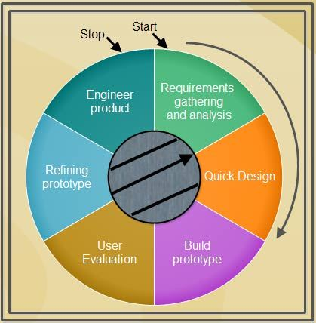

Figure No. 1 Prototyping approach process

This prototyping model applied when detailed information related to input and output requirements of the system is not available. In this model, it is assumed that all the requirements may not be known at the start of the development of the system where there is no manual process to determine the requirements. This model allows the users to interact and experiment with a working model of the system known as prototype. The prototype gives the user an actual feels of the system.

At any stage, if the user is not satisfied with the prototype, it can be discarded and an entirely new system can be developed. Generally, prototype can be prepared by the approaches listed below.

Requirements gathering and analysis: A prototyping model begins with requirements analysis and the requirements of the system are defined in detail. The user is interviewed in order to know the requirement of the system.

*The developers need to conduct a research about the different kinds of transportation in the Philippines and also the causes why people often searching for another mode of transportation; they must gather information and data that will help them to build the project and obtain its objectives.*

Quick design: When requirements are known, a preliminary design or quick design for the system is created. It is not detailed design and includes only the important aspects of the system, which gives an idea of the system to the user. A quick design helps in developing the prototype.

*In this phase, the developers designed the system and they considered all the important aspects required by it. They must also know and obtained all the components needed for the project.*

Build prototype: Information gathered from quick design is modified to form the first prototype, which represent the working model of the required system.

*The developers made the modification of the first prototype in this phase. This prototype will be the working model of the project. It must comply with the requirements of the system to build a good prototype.*

User evaluation: Next, the proposed system is presented to the user for through evaluation of the prototype to recognize its strengths and weaknesses such as what is to be added or removed. Comments and suggestions are collected from the users and provided to the developer.

*In this stage, the developers need to present their finish prototype for the testing and evaluation of the user. They must obtained all the bugs and malfunction of the system as well as the parts that needed improvement and maintenance.*

Refining prototype: Once the user evaluates the prototype and if he is not satisfied, the current prototype is refined according the requirements. That is, new prototype is developed with the additional information provided by the user. The new prototype is evaluated just like the previous prototype. This process continues until all the requirements specified by the user are met. Once the user is satisfied with the developed prototype, a final system is developed on the basis of the final prototype.

*In this phase, the developers are going to review all the things they had gathered from the conducted evaluation. They must refined and improve the prototype to meet the requirement of the project and also to satisfy the needs of the user.*

Engineer product: Once the requirements are completely met, the user accepts the final prototype. The final system is evaluated thoroughly, followed by the routine maintenance on regular basis for preventing large-scale features and minimizing downtime.

*The proponents must acquire the final product of the project. The project must meet all the requirements of the system and ready to use by the users.*

## Hardware/Software

For the developers to make this project, a variety of hardware and software components should be integrated to produce the project.

Hardware

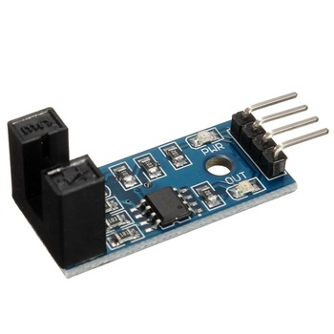 Listed below are the hardware components that the developers are going to use to build the system. They will help to create an efficient and durable prototype of the system.

Figure No. 2 Lm-393 speed sensor

Widely used in motor speed detection, pulse count, the position limit, etc. The DO output interface can be directly connected to a micro-controller IO port, if there is a block detection sensor, such as the speed of the motor encoder can detect. DO modules can be connected to the relay, limit switch, and other functions, it can also with the active buzzer module, compose alarm.

This IR speed module sensor with the comparator LM393, it can calculate the speed of rotation of the wheels of our robot. If the proponents place a ring gear that rotates attached to the wheel.

It could also be used as an optical switch. The basic operation of this sensor is as follows; If anything is passed between the sensor slot, it creates a digital pulse on the D0 pin. This pulse goes from 0V to 5V and is a digital TTL signal. Then with Arduino we can read this pulse.

This IR speed module sensor with the comparator LM393, we can calculate the speedof rotation of the wheels of our robot. If we place a ring gear that rotates attached to ourwheel. It could also be used as an optical switch.The basic operation of this sensor is as follows; If anything is passed between thesensor slot, it creates a digital pulse on the D0 pin. This pulse goes from 0V to 5V and is adigital TTL signal. Then with Arduino we can read this pulse.Widely used in motor speed detection, pulse count, the position limit, etc. The DOoutput interface can be directly connected to a micro-controller IO port, if there is a blockdetection sensor, such as the speed of the motor encoder can detect.DO modules can be connected to the relay, limit switch, and other functions, it can also with the active buzzer module, compose alarm.

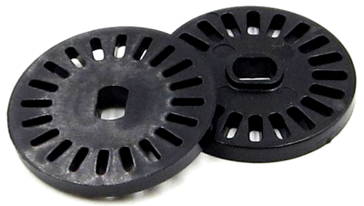

Figure No. 3 Infrared Light sensor

An infrared sensor is an electronic instrument that is used to sense certain characteristics of its surroundings. It does this by either emitting or detecting infrared radiation. Infrared sensors are also capable of measuring the heat being emitted by an object and detecting motion.

Infrared technology is found not just in industry, but also in every-day life. Televisions, for example, use an infrared detector to interpret the signals sent from a remote control. Passive Infrared sensors are used for motion detection systems, and LDR sensors are used for outdoor lighting systems. The key benefits of infrared sensors include their low power requirements, their simple circuitry and their portable features.

Infrared waves are not visible to the human eye. In the electromagnetic spectrum, infrared radiation can be found between the visible and microwave regions. The infrared waves typically have wavelengths between 0.75 and 1000µm.

The infrared spectrum can be split into near IR, mid IR and far IR. The wavelength region from 0.75 to 3µm is known as the near infrared region. The region between 3 and 6µm is known as the mid-infrared region, and infrared radiation which has a wavelength greater higher than 6µm is known as far infrared.

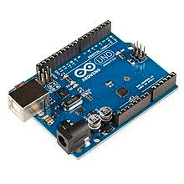

Figure No. 4 Arduino Uno (R3)

The Arduino UNO is an open-source microcontroller board based on the Microchip ATmega328P microcontroller and developed by Arduino.cc. The board is equipped with sets of digital and analog input/output (I/O) pins that may be interfaced to various expansion boards (shields) and other circuits. The board has 14 Digital pins, 6 Analog pins, and programmable with the Arduino IDE (Integrated Development Environment) via a type B USB cable. It can be powered by a USB cable or by an external 9 volt battery, though it accepts voltages between 7 and 20 volts. It is also similar to the Arduino Nano and Leonardo. The hardware reference design is distributed under a Creative Commons Attribution Share-Alike 2.5 license and is available on the Arduino website. Layout and production files for some versions of the hardware are also available. "Uno" means one in Italian and was chosen to mark the release of Arduino Software (IDE) 1.0. The Uno board and version 1.0 of Arduino Software (IDE) were the reference versions of Arduino, now evolved to newer releases. The Uno board is the first in a series of USB Arduino boards, and the reference model for the Arduinoplatform.The ATmega328 on the Arduino Uno comes preprogrammed with a bootloader that allows uploading new code to it without the use of an external hardware programmer. It communicates using the original STK500 protocol. The Uno also differs from all preceding boards in that it does not use the FTDI USB-to-serial driver chip. Instead, it uses the Atmega16U2 (Atmega8U2 up to version R2) programmed as a USB-to-serial converter.The Uno is a huge option for your initial Arduino. It consists of 14-digital I/O pins, where 6-pins can be used as PWM([pulse width modulation](https://www.elprocus.com/pulse-width-modulation-pwm/" \t "_blank) outputs), 6-analog inputs, a reset button, a power jack, a USB connection and more. It includes everything required to hold up the microcontroller; simply attach it to a PC with the help of a USB cable and give the supply to get started with an AC-to-DC adapter or battery. This kind of Arduino has a 16MHz ATmega328 of processor, 2KB SRAM, 32KB flash of Memory, 14 Digital I/O and 6 input, 0 output Analogue I/O.

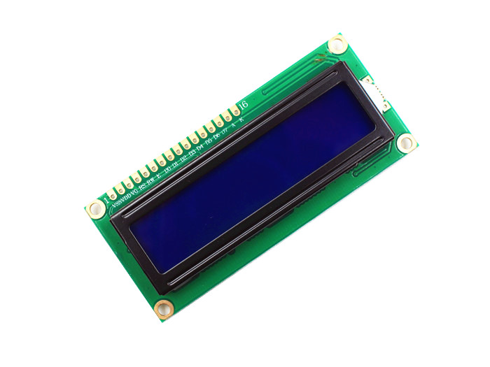

Figure No. 5 LCD (16x2)

LCD (Liquid Crystal Display) screen is an electronic display module and find a wide range of applications. A 16x2 LCD display is very basic module and is very commonly used in various devices and circuits. These modules are preferred over seven segments and other multi segment LEDs. The reasons being: LCDs are economical; easily programmable; have no limitation of displaying special & even custom characters (unlike in seven segments), animations and so on.

A 16x2 LCD means it can display 16 characters per line and there are 2 such lines. In this LCD each character is displayed in 5x7 pixel matrix. This LCD has two registers, namely, Command and Data.

The command register stores the command instructions given to the LCD. A command is an instruction given to LCD to do a predefined task like initializing it, clearing its screen, setting the cursor position, controlling display etc. The data register stores the data to be displayed on the LCD. The data is the ASCII value of the character to be displayed on the LCD. Click to learn more about internal structure of a LCD.

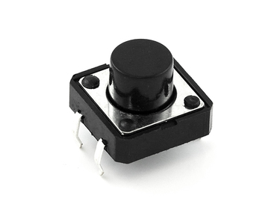

Figure No. 6 Push Button

A push button is a simple type of switch that controls an action in a machine or some type of process. Most of the time, the buttons are plastic or metal. The shape of the push button may conform to fingers or hands for easy use, or they may simply be flat. It all depends on the individual design. The push button can be normally open or normally closed.

Push button switches have three parts. The actuator, stationary contacts, and the grooves. The actuator will go all the way through the switch and into a thin cylinder at the bottom. Inside is a movable contact and spring. When someone presses the button, it touches with the stationary contacts, causing the action to take place. In some cases, the user needs to keep holding the button, or to press it repeatedly, for an action to take place. With other push buttons, a latch connects and keeps the switch on until the user presses the button again.

Push button switches are popular in a variety of different applications, including calculators, push button phones, and many home appliances. You can find them in the home, the office, and in industrial applications today. They can turn machines on and off, or cause the devices to perform specific actions, as is the case with calculators. In some cases, specifically for commercial and industrial usage, the buttons can connect through mechanical linkage, which means that pushing one button can actually cause another button to release.

In many cases, the buttons will have specific coloration to help denote their actions. This ensures that the chance of someone pushing the button by mistake is lower. Red will usually indicate stopping, while green generally indicates starting a machine. Emergency stop buttons, which tend to be large push buttons, are generally red, and they typically have larger heads for easier use.

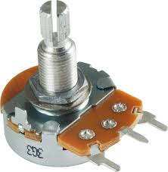

Figure No. 7 Potentiometer

A potentiometer is a manually adjustable variable resistor with 3 terminals. Two terminals are connected to both ends of a resistive element, and the third terminal connects to a sliding contact, called a wiper, moving over the resistive element. The position of the wiper determines the output voltage of the potentiometer. The potentiometer essentially functions as a variable voltage divider. The resistive element can be seen as two resistors in series (potentiometer resistance), where the wiper position determines the resistance ratio of the first resistor to the second resistor.

A potentiometer is also commonly known as a potmeter or pot. The most common form of potmeter is the single turn rotary potmeter. This type of pot is often used in audio volume control (logarithmic taper) as well as many other applications. Different materials are used to construct potentiometers, including carbon composition, cermet, wire wound, and conductive plastic or metal film.

A wide variety of potmeters exist. Manually adjustable potmeters can be divided in rotary or linear movement types. The tables below list the available types and their applications. Besides manually adjustable pots, also electronically controlled potentiometers exist, often called digital potmeters.

Digital potentiometers are potentiometers which are controlled electronically. In most cases they exist of an array of small resistive components in series. Every resistive element is equipped with a switch which can serve as the tap-off point or virtual wiper position. A digital potmeter can be controlled by for example up/down signals or protocols like I²C and SPI.

A potentiometer can also be wired as a rheostat, or single variable resistance. The best way to wire a potentiometer as a rheostat is to connect the wiper and one end terminal together, this prevents infinite resistance if the wiper occasionally loses contact.

The measuring instrument called a potentiometer is essentially a voltage divider used for measuring electric potential (voltage); the component is an implementation of the same principle, hence its name.

Potentiometers are commonly used to control electrical devices such as volume controls on audio equipment. Potentiometers operated by a mechanism can be used as position transducers, for example, in a joystick. Potentiometers are rarely used to directly control significant power (more than a watt), since the power dissipated in the potentiometer would be comparable to the power in the controlled load.

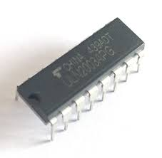

Figure No. 8 ULN2003 Motor Driver IC

The ULN2003A is an array of seven NPN Darlington transistors capable of 500 mA, 50 V output. It features common-cathode flyback diodes for switching inductive loads. It can come in PDIP, SOIC, SOP or TSSOP packaging. In the same family are ULN2002A, ULN2004A, as well as ULQ2003A and ULQ2004A, designed for different logic input levels.

The ULN2003A is also similar to the ULN2001A (4 inputs) and the ULN2801A, ULN2802A, ULN2803A, ULN2804A and ULN2805A, only differing in logic input levels (TTL, CMOS, PMOS) and number of in/outputs (4/7/8).

The ULN2003 is known for its high-current, high-voltage capacity. The drivers can be paralleled for even higher current output. Even further, stacking one chip on top of another, both electrically and physically, has been done. Generally it can also be used for interfacing with a stepper motor, where the motor requires high ratings which cannot be provided by other interfacing devices. A Darlington transistor (also known as Darlington pair) achieves very high current amplification by connecting two bipolar transistors in direct DC coupling so the current amplified by the first transistor is amplified further by the second one. The seven Darlington pairs in ULN2003 can operate independently except the common cathode diodes that connect to their respective collectors.

Step motor is to a machine to convert pulse to angle displacement. So if you give stepper driver a certain pulse signal, it will drive step motor to a certain angle. you can control the angle the stepper moved by the number of the pulse. And you also can control the speed of the stepper rotate by the frequency of the pulse. The following picture is the schematic of the stepper driver.

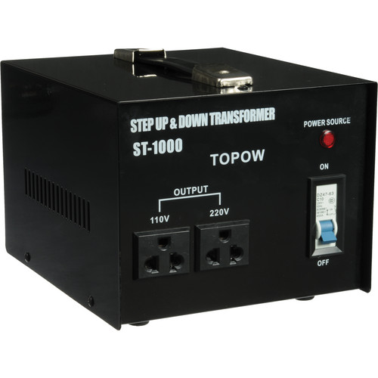

Figure No. 9 Power Supply

A power supply is an electrical device that supplies electric power to an electrical load. The primary function of a power supply is to convert electric current from a source to the correct voltage, current, and frequency to power the load. As a result, power supplies are sometimes referred to as electric power converters. Some power supplies are separate standalone pieces of equipment, while others are built into the load appliances that they power. Examples of the latter include power supplies found in desktop computers and consumer electronics devices. Other functions that power supplies may perform include limiting the current drawn by the load to safe levels, shutting off the current in the event of an electrical fault, power conditioning to prevent electronic noise or voltage surges on the input from reaching the load, power-factor correction, and storing energy so it can continue to power the load in the event of a temporary interruption in the source power (uninterruptible power supply).

All power supplies have a *power input* connection, which receives energy in the form of electric current from a source, and one or more *power output* connections that deliver current to the load. The source power may come from the electric power grid, such as an electrical outlet, energy storage devices such as batteries or fuel cells, generators or alternators, solar power converters, or another power supply. The input and output are usually hardwired circuit connections, though some power supplies employ wireless energy transfer to power their loads without wired connections. Some power supplies have other types of inputs and outputs as well, for functions such as external monitoring and control.

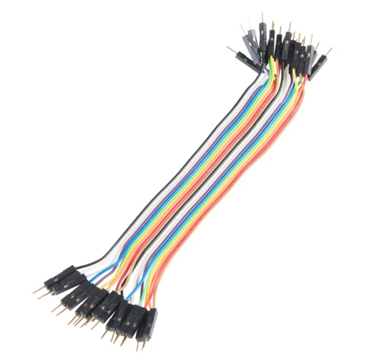

Figure No. 10 Connecting Wires

Connecting wires allows an electrical current to travel from one point on a circuit to another because electricity needs a medium through which it can move. Most of the connecting wires are made up of copper or aluminum. Copper is cheap and good conductivity. Instead of the copper, we can also use silver which has high conductivity but it is too costly to use.

Wire gauges come in various standard sizes, as expressed in terms of a gauge number. The term *wire* is also used more loosely to refer to a bundle of such strands, as in "multistranded wire", which is more correctly termed a wire rope in mechanics, or a cable in electricity.

Wire comes in solid core, stranded, or braided forms. Although usually circular in cross-section, wire can be made in square, hexagonal, flattened rectangular, or other cross-sections, either for decorative purposes, or for technical purposes such as high-efficiency voice coils in loudspeakers. Edge-wound coil springs, such as the Slinky toy, are made of special flattened wire.

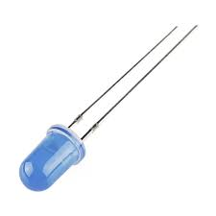

Figure No. 10 LED

A light-emitting diode (LED) is a semiconductor light source that emits light when current flows through it. Electrons in the semiconductor recombine with electron holes, releasing energy in the form of photons. This effect is called electroluminescence. The color of the light (corresponding to the energy of the photons) is determined by the energy required for electrons to cross the band gap of the semiconductor. White light is obtained by using multiple semiconductors or a layer of light-emitting phosphor on the semiconductor device. Appearing as practical electronic components in 1962, the earliest LEDs emitted low-intensity infrared light. Infrared LEDs are used in remote-control circuits, such as those used with a wide variety of consumer electronics. The first visible-light LEDs were of low intensity and limited to red. Modern LEDs are available across the visible, ultraviolet, and infrared wavelengths, with high light output.

Early LEDs were often used as indicator lamps, replacing small incandescent bulbs, and in seven-segment displays. Recent developments have produced white-light LEDs suitable for room lighting. LEDs have led to new displays and sensors, while their high switching rates are useful in advanced communications technology.

LEDs have many advantages over incandescent light sources, including lower energy consumption, longer lifetime, improved physical robustness, smaller size, and faster switching. Light-emitting diodes are used in applications as diverse as aviation lighting, automotive headlamps, advertising, general lighting, traffic signals, camera flashes, lighted wallpaper and medical devices.

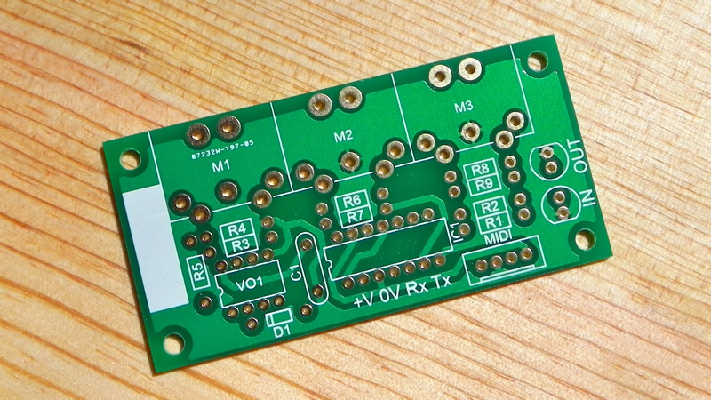

Figure No. 11 PCB Board

A printed circuit board (PCB) mechanically supports and electrically connects electronic components or electrical components using conductive tracks, pads and other features etched from one or more sheet layers of copper laminated onto and/or between sheet layers of a non-conductive substrate. Components are generally soldered onto the PCB to both electrically connect and mechanically fasten them to it.

Printed circuit boards are used in all but the simplest electronic products. They are also used in some electrical products, such as passive switch boxes.

Alternatives to PCBs include wire wrap and point-to-point construction, both once popular but now rarely used. PCBs require additional design effort to lay out the circuit, but manufacturing and assembly can be automated. Specialized CAD software is available to do much of the work of layout. Mass-producing circuits with PCBs is cheaper and faster than with other wiring methods, as components are mounted and wired in one operation. Large numbers of PCBs can be fabricated at the same time, and the layout only has to be done once. PCBs can also be made manually in small quantities, with reduced benefits.

PCBs can be single-sided (one copper layer), double-sided (two copper layers on both sides of one substrate layer), or multi-layer (outer and inner layers of copper, alternating with layers of substrate). Multi-layer PCBs allow for much higher component density, because circuit traces on the inner layers would otherwise take up surface space between components. The rise in popularity of multilayer PCBs with more than two, and especially with more than four, copper planes was concurrent with the adoption of surface mount technology.

Software

These are the software programs that developers going to use to design and create modules and other programming. This Software’s will help to make some of the work don easily.



Figure No. 12Arduino IDE

The Arduino integrated development environment (IDE) is a cross-platform application (for Windows, macOS, Linux) that is written in the programming language Java. It is used to write and upload programs to Arduino board.

The source code for the IDE is released under the GNU General Public License, version 2. The Arduino IDE supports the languages C and C++ using special rules of code structuring. The Arduino IDE supplies a software library from the Wiring project, which provides many common input and output procedures. User-written code only requires two basic functions, for starting the sketch and the main program loop, that are compiled and linked with a program stub *main()* into an executable cyclic executive program with the GNU toolchain, also included with the IDE distribution. The Arduino IDE employs the program *avrdude* to convert the executable code into a text file in hexadecimal encoding that is loaded into the Arduino board by a loader program in the board's firmware.

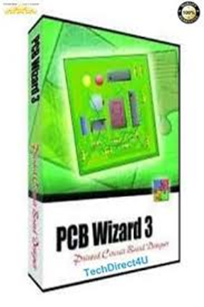

Figure No. 13 PCB Wizard

PCB Wizard 3is an easy-to-use package for designing single-sided and double-sided printed circuit boards (PCBs).

It provides a comprehensive range of tools covering all the traditional steps in PCB production, including schematic drawing, schematic capture, component placement, automatic routing, Bill of Materials reporting and file generation for manufacturing. In addition, PCB Wizard 3 offers a wealth of clever new features that do away with the steep learning curve normally associated with PCB packages.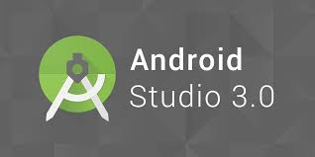

Figure No. 14 Arduino IDE

Android Studio is the official integrated development environment (IDE) for Google's Android operating system, built on JetBrains' IntelliJ IDEA software and designed specifically for Android development. It is available for download on Windows, macOS and Linux based operating systems. It is a replacement for the Eclipse Android Development Tools (ADT) as the primary IDE for native Android application development.

Android Studio was announced on May 16, 2013 at the Google I/O conference. It was in early access preview stage starting from version 0.1 in May 2013, then entered beta stage starting from version 0.8 which was released in June 2014.The first stable build was released in December 2014, starting from version 1.0.The current stable version is 3.3, which was released in January 2019.

Android Studio supports all the same programming languages of IntelliJ (and CLion) e.g. Java, C++, and more with extensions, such as Go;and Android Studio 3.0 or later supports Kotlin and "Java 7 language features and a subset of Java 8 language features that vary by platform version." External projects backport some Java 9 features.WhileIntelliJ that Android Studio is built on supports all released Java versions, and Java 12, it is not clear to what level Android Studio supports Java versions up to Java 12 (the documentation mentions partial Java 8 support). At least some new language features up to Java 12 are usable in Android.

## Calendar of Activities

In this section should contain the detailed sequence of activities that the proponents will undergo in completing the thesis project. This should discuss the activities, purpose or objectives of each activity, persons involved and the resources needed in chronological

order of execution.

SURVEY FORM

How often do you ride a tricycle?

What is the regular fare in tricycle?

What are the factors that affects in increasing the fare.

1.

2.

Do you think that tricycle fare is reasonable?

Is it okay for you to have a meter on a tricycle?

Do you think it will effect the current fare of the tricycle?

Do you agree in implementing fare matrix in tricycle?

SYSTEM DIAGRAM

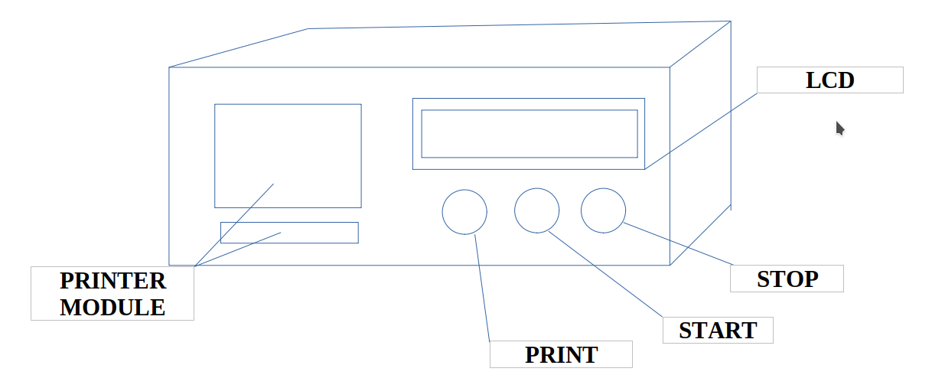

Figure No. 15 System Diagram

This is the front view of the system it has LCD module to view the price and distance traveled and it has start button to start the calculation of the fare and it has the stop button to stop recording the fare and at the same the reset and it has the print button print the receipt of the passenger and it has printer module to generate the copy of receipt both passenger and the driver.

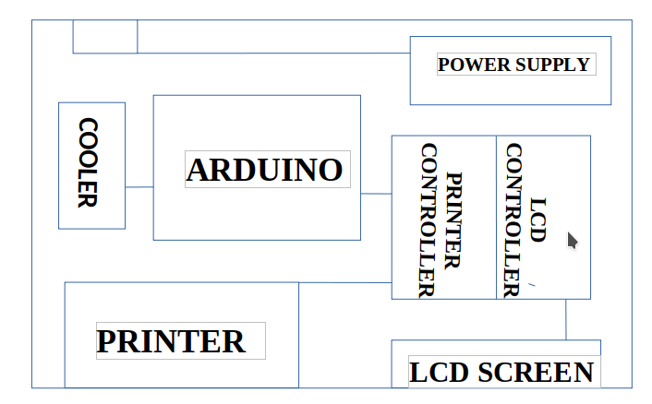Figure No. 16 System Diagram

This is the top view and parts of the system it has cooler to prevent overheat and it has power supply that produce 12v to supply current in the system and it has arduinouno help the system to connect and to control all parts of the system and it has printer device that will generate receipt and it has lcd screen to help the user to view all transaction and it has lcd controller connected to the lcd screen to control the output of the lcd screen and lastly it has printer controller that connected to the printer device it will control the data that will generate and print in the printer device.

**Gantt chart of Activities**

|  |  |  |  |  |  |  |  |  |  |  |  |  |  |  |  |  |  |  |  |  |  |  |  |  |  |  |  |  |  |  |  |  |  |  |  |  |  |  |  |  |  |  |  |  |  |  |  |  |  |  |  |  |  |  |  |  |  |  |  |  |  |  |  |  |  |  |  |  |  |  |  |  |  |  |  |  |  |  |  |  |  |  |  |  |  |  |  |  |  |  |  |  |  |  |  |  |  |  |  |  |  |  |  |  |  |  |
| --- | --- | --- | --- | --- | --- | --- | --- | --- | --- | --- | --- | --- | --- | --- | --- | --- | --- | --- | --- | --- | --- | --- | --- | --- | --- | --- | --- | --- | --- | --- | --- | --- | --- | --- | --- | --- | --- | --- | --- | --- | --- | --- | --- | --- | --- | --- | --- | --- | --- | --- | --- | --- | --- | --- | --- | --- | --- | --- | --- | --- | --- | --- | --- | --- | --- | --- | --- | --- | --- | --- | --- | --- | --- | --- | --- | --- | --- | --- | --- | --- | --- | --- | --- | --- | --- | --- | --- | --- | --- | --- | --- | --- | --- | --- | --- | --- | --- | --- | --- | --- | --- | --- | --- | --- | --- | --- |
| MONTH | | | | | JUNE | | | | | | | | JULY | | | | | | | | | AUGUST | | | | | | | | SEPTEMBER | | | | | | | | | OCTOBER | | | | | | | NOVEMBER | | | | | | | | | DECEMBER | | | | | | | | JANUARY | | | | | | | | | | FEBRUARY | | | | | | | | | MARCH | | | | | | | | April | | | | | | | | | May | | | | | | | |
| ACTIVITY | | | | |
| Planning | | | | |  | |  | |  | |  | | |  | |  | |  | |  | |  | |  | |  | |  | | |  | |  | |  | |  | |  | |  | |  |  | | |  | |  | |  | |  | | |  | |  | |  | |  | | |  | |  | |  |  | |  | | |  | |  | |  | |  | | |  | |  | |  | | |  | |  | |  | |  | | |  | |  | |  |  |
| Requirements Gathering and Analysis | | | | |  | |  | |  | |  | | |  | |  | |  | |  | |  | |  | |  | |  | | |  | |  | |  | |  | |  | |  | |  |  | | |  | |  | |  | |  | | |  | |  | |  | |  | | |  | |  | |  |  | |  | | |  | |  | |  | |  | | |  | |  | |  | | |  | |  | |  | |  | | |  | |  | |  |  |
| Quick Design | | | | |  | |  | |  | |  | | |  | |  | |  | |  | |  | |  | |  | |  | | |  | |  | |  | |  | |  | |  | |  |  | | |  | |  | |  | |  | | |  | |  | |  | |  | | |  | |  | |  |  | |  | | |  | |  | |  | |  | | |  | |  | |  | | |  | |  | |  | |  | | |  | |  | |  |  |
| Build Prototype | | | | |  | |  | |  | |  | | |  | |  | |  | |  | |  | |  | |  | |  | | |  | |  | |  | |  | |  | |  | |  |  | | |  | |  | |  | |  | | |  | |  | |  | |  | | |  | |  | |  |  | |  | | |  | |  | |  | |  | | |  | |  | |  | | |  | |  | |  | |  | | |  | |  | |  |  |
| User Evaluation | | | | |  | |  | |  | |  | | |  | |  | |  | |  | |  | |  | |  | |  | | |  | |  | |  | |  | |  | |  | |  |  | | |  | |  | |  | |  | | |  | |  | |  | |  | | |  | |  | |  |  | |  | | |  | |  | |  | |  | | |  | |  | |  | | |  | |  | |  | |  | | |  | |  | |  |  |
| Refining Prototype | | | | |  | |  | |  | |  | | |  | |  | |  | |  | |  | |  | |  | |  | | |  | |  | |  | |  | |  | |  | |  |  | | |  | |  | |  | |  | | |  | |  | |  | |  | | |  | |  | |  |  | |  | | |  | |  | |  | |  | | |  | |  | |  | | |  | |  | |  | |  | | |  | |  | |  |  |
| Engineer Product | | | | |  | |  | |  | |  | | |  | |  | |  | |  | |  | |  | |  | |  | | |  | |  | |  | |  | |  | |  | |  |  | | |  | |  | |  | |  | | |  | |  | |  | |  | | |  | |  | |  |  | |  | | |  | |  | |  | |  | | |  | |  | |  | | |  | |  | |  | |  | | |  | |  | |  |  |

## Budgetary Estimate

|  |  |  |
| --- | --- | --- |
| Quantity | Specifics | Approximate Cost |
| 1 | Arduino UNO (R3) | 2000 |
| 1 | LCD (16x2) | 400 |
| 14 | Push Button | 150 |
| 5 | Potentiometer -10k | 50 |
| 1 | ULN2003 Motor Driver IC | 200 |
| 1 | LM393 Speed Sensor Module (FC-03) | 1500 |
| 1 | RC Smart Car Chassis with Speed encoder | 1000 |
| 1 | Power Supply | 500 |
| 1 | PCB Board | 600 |
| 40 meters | Connecting Wires | 200 |



## Human Resources

The following pages contains the curriculum vitae of the researchers and the Adviser’s Acceptance Form.

Curriculum Vitae of

JOHN ELHIE G, CATAGA

507A Prudencio St. Sampaloc Manila

johnelhiecataga@gmail.com

09355316393

EDUCATIONAL BACKGROUND

|  |  |  |
| --- | --- | --- |
| Level | Inclusive Dates | Name of school/ Institution |
| Tertiary | 2015-*present* | STI College Recto |
| Vocational/Technical |  |  |
| High School | 2012-2015 | Arellano University |
| Elementary | 2010-2012 | National University |

PROFESSIONAL OR VOLUNTEER EXPERIENCE

|  |  |  |
| --- | --- | --- |
| Inclusive Dates | Nature of Experience/  Job Title | Name and Address of Company or Organization |
| 10-12-16 | Student Assistant | Sti - Recto |
|  |  |  |
|  |  |  |
|  |  |  |

Listed in reverse chronological order (most recent first).

AFFILIATIONS

|  |  |  |
| --- | --- | --- |
| Inclusive Dates | Name of Organization | Position |
| 2015-*present* | ICPeP.se | Member |
|  |  |  |
|  |  |  |
|  |  |  |

Listed in reverse chronological order (most recent first).

SKILLS

|  |  |  |
| --- | --- | --- |
| SKILLS | Level of Competency | Date Acquired |
|  |  |  |
|  |  |  |
|  |  |  |

TRAININGS, SEMINARS OR WORKSHOP ATTENDED

|  |  |
| --- | --- |
| Inclusive Dates | Title of Training, Seminar or Workshop |
| 05-07-2016 | How It Works |
|  |  |
|  |  |
|  |  |

Listed in reverse chronological order (most recent first).

Curriculum Vitae of

Juluis M. Dela Vega.

1962-B., P. Florentino St., Sampaloc, Manila

juluisdelavega@gmail.com

+63905-528-8399

EDUCATIONAL BACKGROUND

|  |  |  |
| --- | --- | --- |
| Level | Inclusive Dates | Name of school/ Institution |
| Tertiary | May 2014 | STI-Recto |
| Vocational/Technical | None | None |
| High School | March 2011 | Sta. Ignacia Academy |
| Elementary | March 2007 | SINCES |

PROFESSIONAL OR VOLUNTEER EXPERIENCE

|  |  |  |
| --- | --- | --- |
| Inclusive Dates | Nature of Experience/  Job Title | Name and Address of Company or Organization |
| March 2016  March 2017  March 2018 | Production Assistant | Intercessor for the Philippines |
|  |  |  |
| March 2016  March 2017  March 2018 | Production Assistant | Intercessor for the Philippines |
|  |  |  |

Listed in reverse chronological order (most recent first).

AFFILIATIONS

|  |  |  |
| --- | --- | --- |
| Inclusive Dates | Name of Organization | Position |
| None | None |  |
|  |  |  |
|  |  |  |
|  |  |  |

Listed in reverse chronological order (most recent first).

SKILLS

|  |  |  |
| --- | --- | --- |
| SKILLS | Level of Competency | Date Acquired |
| PC Troubleshooting | Intermediate | March 2012 |
|  |  |  |
|  |  |  |

TRAININGS, SEMINARS OR WORKSHOP ATTENDED

|  |  |
| --- | --- |
| Inclusive Dates | Title of Training, Seminar or Workshop |
|  |  |
|  |  |
|  |  |
|  |  |

Listed in reverse chronological order (most recent first).

Curriculum Vitae of

JEROME B, GABAT

1428 Sandiego St., Sampaloc Manila

jeromegabat14@gmail.com

09051946970

EDUCATIONAL BACKGROUND

|  |  |  |
| --- | --- | --- |
| Level | Inclusive Dates | Name of school/ Institution |
| Tertiary | 2015-*present* | STI College Recto |
| Vocational/Technical |  |  |
| High School | 2012-2015 | Esteban Abada High School |
| Elementary | 2010-2012 | D. Tuazon Elementary School |

PROFESSIONAL OR VOLUNTEER EXPERIENCE

|  |  |  |
| --- | --- | --- |
| Inclusive Dates | Nature of Experience/  Job Title | Name and Address of Company or Organization |
| 10-12-16 | Student Assistant | Sti - Recto |
|  |  |  |
|  |  |  |
|  |  |  |

Listed in reverse chronological order (most recent first).

AFFILIATIONS

|  |  |  |
| --- | --- | --- |
| Inclusive Dates | Name of Organization | Position |
| 2015-*present* | ICPeP.se | Member |
|  |  |  |
|  |  |  |
|  |  |  |

Listed in reverse chronological order (most recent first).

SKILLS

|  |  |  |
| --- | --- | --- |
| SKILLS | Level of Competency | Date Acquired |
|  |  |  |
|  |  |  |
|  |  |  |

TRAININGS, SEMINARS OR WORKSHOP ATTENDED

|  |  |
| --- | --- |
| Inclusive Dates | Title of Training, Seminar or Workshop |
| 05-07-2016 | How It Works |
|  |  |
|  |  |
|  |  |

Listed in reverse chronological order (most recent first).

Curriculum Vitae of

APPLE JEAN M, GARCIA

757 Ortiz Residence Maginhawa St. Malate Manila

garciaapple@gmail.com

09051946970

EDUCATIONAL BACKGROUND

|  |  |  |
| --- | --- | --- |
| Level | Inclusive Dates | Name of school/ Institution |
| Tertiary | 2014-*present* | STI College Recto |
| Vocational/Technical |  |  |
| High School | 2012-2015 | Villa Domingo National High School |
| Elementary | 2010-2012 | Viga Elementary School |

PROFESSIONAL OR VOLUNTEER EXPERIENCE

|  |  |  |
| --- | --- | --- |
| Inclusive Dates | Nature of Experience/  Job Title | Name and Address of Company or Organization |
| 10-12-16 | Student Assistant | Sti - Recto |
|  |  |  |
|  |  |  |
|  |  |  |

Listed in reverse chronological order (most recent first).

AFFILIATIONS

|  |  |  |
| --- | --- | --- |
| Inclusive Dates | Name of Organization | Position |
| 2015-*present* | ICPeP.se | Member |
|  |  |  |
|  |  |  |
|  |  |  |

Listed in reverse chronological order (most recent first).

SKILLS

|  |  |  |
| --- | --- | --- |
| SKILLS | Level of Competency | Date Acquired |
|  |  |  |
|  |  |  |
|  |  |  |

TRAININGS, SEMINARS OR WORKSHOP ATTENDED

|  |  |
| --- | --- |
| Inclusive Dates | Title of Training, Seminar or Workshop |
| 05-07-2016 | How It Works |
|  |  |
|  |  |
|  |  |

Listed in reverse chronological order (most recent first).

ADVISER’S ACCEPTANCE FORM

NAME OF PROPONENTS: Cataga, John Elhie G

Dela Vega, Juluis M.

Gabat, Jerome B.

Garcia, Apple Jean M.

APPROVED RESEARCHE TITLE: Automated Tricycle Fare Meter

AREA OF STUDY: Design Project

CONFORME:

Engr. Elizier L. Obamos, ME, CpE

Thesis

APPROVED BY:

Engr. Elizier L. Obamos, ME, CpE Date: November 2019

Thesis Coordinator

NOTED BY:

Engr. Elizier L. Obamos, ME, CpE

Program Head

# References

Angkas is a simple new, motorcycle-based ride-hailing platform from <https://www.topgear.com.ph/news/industry.../angkas-ride-hailing-a00013-20170626>

Arduino Handbook, Guide to Arduino from <https://www.arduino.cc/en/guide/environment>

Arduino Uno - R3 SMD - DEV-11224 - SparkFun Electronics from <https://www.sparkfun.com/products/11224>

Arduino Uno R3 Microcontroller - Trossen Robotics from <https://www.trossenrobotics.com/p/arduino-uno.aspx>

Download Arduino IDE - free - latest version from https://arduino-ide.en.softonic.com › Windows › Development & IT › Arduino IDE

Everything You Need To Know About LED Lighting - Stouch Lighting from <https://www.stouchlighting.com/blog/all-about-led-lighting-what-does-led-stand-for>

Get Arduino IDE - Microsoft Store from <https://www.microsoft.com/en-us/p/arduino-ide/9nblggh4rsd8>

Grab - Transport, Food Delivery, Payments - Apps on Google Play from <https://play.google.com/store/apps/details?id=com.grabtaxi.passenger&hl=en>

How Taxi Meters Work | HowStuffWorks from https://auto.howstuffworks.com › Auto › Auto Basics

How to Interface LM393 Speed Sensor with Arduino? - Electronics Hub from https://www.electronicshub.org › Arduino

How to measure the speed of a DC motor using an LM393 IR speed from <https://www.quora.com/How-do-I-measure-the-speed-of-a-DC-motor-using-an-LM393>

How to use a Speed Sensor with Arduino – Brainy-Bits from https://www.brainy-bits.com › Tutorials

https://www.rappler.com/move-ph/188949-angkas-passengers-riders from Why passengers and bikers think Angkas matters – Rappler

Introduction to Arduino Uno - The Engineering Projects from https://www.theengineeringprojects.com › Arduino

Lm393 Motor Speed Measuring Sensor Module ForArduino from <https://5.imimg.com/.../lm393-motor-speed-measuring-sensor-module-for-arduino.pdf>

PCB Wizard 3 - Products - New Wave Concepts Limited from <https://www.new-wave-concepts.com/ed/wizard.html>

PCB Wizard Alternatives and Similar Software – AlternativeTo.net from <https://alternativeto.net/software/pcb-wizard/>

PCB Wizard products and sales from <https://electricdruid.net/product/midi-inoutthru-pcb/>

Pololu - Arduino Uno R3 from <https://www.pololu.com/product/2191>

Potentiometer » Resistor Guide from [www.resistorguide.com/potentiometer](http://www.resistorguide.com/potentiometer)

Potentiometer, Preset Potentiometers and Rheostats from <https://www.electronics-tutorials.ws/resistor/potentiometer.html>

Push Button | RS Components from <https://uk.rs-online.com/web/generalDisplay.html?id=solutions/push-button-switches>

Push-button | Definition of Push-button by Merriam-Webster from <https://www.merriam-webster.com/dictionary/push-button>

Relay Driver Circuit using IC ULN2003 with Applications – ElProCus from <https://www.elprocus.com/relay-driver-circuit-using-uln2003/>

Ride Hailing Platform: Car, Taxi & Carpool | Grab from <https://www.grab.com/ph/>

Robotics 4WD RC Smart Car Chassis for Arduino from <https://www.robotics.org.za/RBP68138C>

ULN2003 Stepper Motor Drivers - Electronicos Caldas from <https://www.electronicoscaldas.com/datasheet/ULN2003A-PCB.pdf>

What is an LED? - LEDs from <https://www.ledsmagazine.com/articles/2004/01/what-is-an-led.html>

What is GrabCar? | Grab PH from https://www.grab.com › ... › GrabCar › What is GrabCar?

What Is Uber and How Do You Use it? From <https://www.uber.com/au/en/ride/how-it-works/>

What Is Uber Exactly? Here's How It Works. - Uber Estimate from uberestimate.com/about-uber/